 |  |  |  |  |  |  |  |  |  |  |  |  |  |  |  |  |  |  |  |  |  |  |  |  |  |  | Print Form
 |  |  |  |  |  |  |  |  |  |  |  |  |  |  |  | Carrollton Volunteer Fire Department
 |  |  |  |  |  |  |  |  |  |  |  |  |  |  |  |  |  |  | Membership Application
 |  |  | Regular Membership |  |  |  |  |  |  |  |  |  |  |  |  |  |  |  | Junior / Apprentice Membership
 |  |  | Name: |  |  |  |  |  |  |  |  |  |  |  |  |  |  |  |  |  |  |  | Date:
 |  |  | Address: |  |  |  |  |  |  |  |  |  |  |  |  | City: |  |  |  |  |  |  | State: |  |  |  | Zip:
 |  |  | Home Phone: |  |  |  |  |  |  |  |  | Cell Phone: |  |  |  |  |  |  |  |  | Other | Phone:
 |  |  | Email address:
 |  |  | DOB: |  |  |  |  |  |  |  |  | Blood Type: |  |  |  |  |  |  |  |  | Driver License #:
 |  |  |  |  |  |  |  |  |  |  |  |  | Family Information
 |  |  | Family Physician: |  |  |  |  |  |  |  |  |  |  |  |  |  |  | Physicians Phone #:
 |  |  | Family Physician Address:
 |  |  | Marital Status:
 |  |  |  |  |  |  | Single |  |  |  |  |  | Married |  |  |  |  |  | Divorced |  |  |  |  |  | Widowed
 |  |  | Emergency Contact |  |  |  | Information:
 |  |  | Contact Name: |  |  |  |  |  |  |  |  | Contact Address: |  |  |  |  |  |  |  |  | Contact Phone #"
 |  |  | Have you had any health problems during the last five |  |  |  |  |  |  |  | years? (Heart Problems, Asthma, Breathing Difficulties, |  |  |  |  |  |  |  |  |  | Physical Problems, Disease, etc).
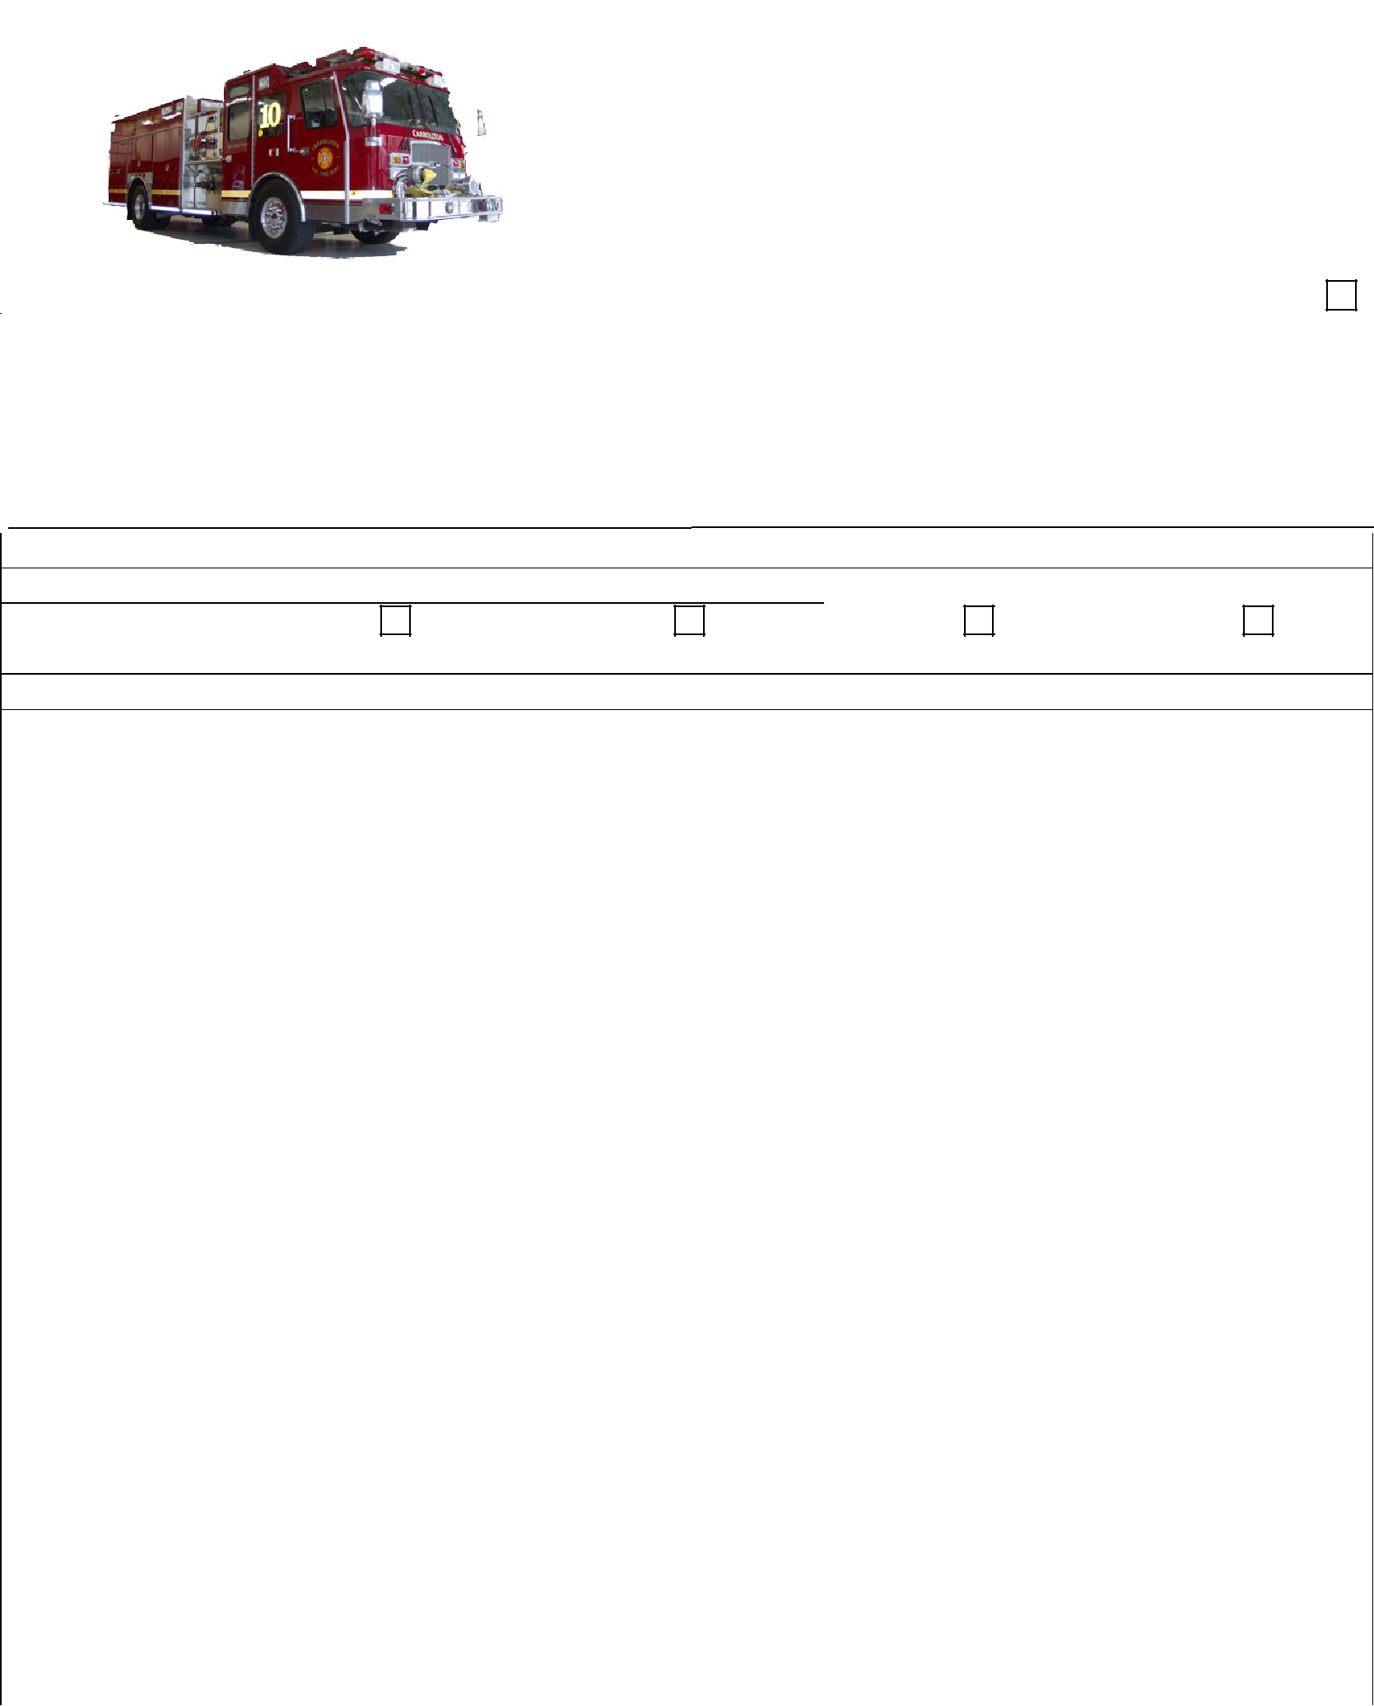

Yes No If yes, please explain:

Are you currently drawing Workman's Compensation for any reason?

Yes No If yes, please explain:

Are you Claustrophobic? _{Yes} | No |  | Are you afraid of Heights? _{Yes} | No
Are you a member of any other Volunteer or Civic Organizations? _{Yes} |  | No | Name of organization:
Tell why you want to volunteer for Carrollton Volunteer Fire Department:

Any member, with the exception of junior members and military members, must possess a valid Virginia Driver's License. The Applicant must also present a current and legal copy of his/her driving record (available from DMV) with this application.

According to Part II EMS Agency, EMS Vehicle and EMS Personnel Standards Article I EMS Agency Licensure Requirements 12 VAC 5-31-540 Personnel records.

- An EMS agency shall have a record for each individual affiliated with the EMS agency documenting the results of a criminal history background check conducted through the Central Criminal Records Exchange operated by the Virginia State Police no more than 60 days prior to the individual's affiliation with the EMS Agency.

The Criminal History record must be received back from OEMS prior to being voted onto probation. Further instructions are included on the last page.

 | References
Please list 3 reference we may contact, who are not related to you:
Name: | Phone:
Address: | City: | State: | Zip:
Name: | Phone:
Address: | City: | State: | Zip:
Name: | Phone:
Address: | City: | State: | Zip:

Do you currently hold any Virginia Department of Fire Programs or Emergency Medical Services Certifications:
Yes No

Type | Certification # if Applicable | Expiration Date
ex: EMT-P (Paramedic) | B122509301 | 12/25/99

If elected to membership, the applicant shall serve a six month probationary period. Within that six month probationary period the applicant must obtain a valid CPR "American Heart" card and complete the proper FEMA/NIMS classes. Within one year of joining the Fire Department, a new member must complete an Emergency Medical Technician (EMT) course approved by the office of EMS, or the Fire Fighter I/II course approved by the Department of Fire Programs respectively, or provides evidence of completion of this course or a training course equivalent to Fire Fighter I. If the so mentioned training has not been completed by a new member within the allotted time frame, the department may extend the training period by six (6) months with a 2/3 vote of a quorum of the membership. If applicant has not completed the required training within the additional time, he or she will be dropped from the department.

Public Safety Volunteers are now required by FEMA to complete several courses in order for the volunteer agency to continue to receive grants. If you currently do not have any FEMA/NIMS Courses, you will be required to complete the minimum requirements prior to the six (6) month probationary period ending. If the so minimum requirements as indicated below are not met, the department may extend the period by two (2) months with a 2/3 vote of a quorum of the membership. If the minimum requirements are not met within the additional time, he or she will be dropped from the department. The courses can be taken online at http://training.fema.gov/IS/crslist.asp.

 | Fire Fighter / EMT |  |  | ISO-100, 700
 | Officer of the Department |  | ISO - 100, 200, 700 & 800
 | Fire Chief / Deputy Chief / Assistant Chief |  | ISO - 100, 200, 300, 400, 700, & 800

Junior and Apprentice Members section only
Junior and apprentice members must have signature permission from a parent or legal guardian to become a member with Carrollton Volunteer Fire Department. Junior and apprentice members must also submit photo copies of report cards to the Chief or his designee while school is in session.

Mother | Date
Father | Date
To submit this application, you must be present at a Carrollton Volunteer Fire Department regular business
meeting that is held the last Thursday of each month. At this meeting your application, will be presented to the

membership. After this meeting, you will meet with the membership committee to review your application, discuss the probationary procedures, and answer any questions. If you have any questions regarding this

process, please email them to membership@carrolltonfiredept.org

The Applicant, who resides in the Carrollton Volunteer Fire Department Run District, or lives outside the Carrollton Volunteer Fire Department Run District, fully understands the guidelines of outside district membership, freely and voluntarily offers his/her membership to Carrollton Volunteer Fire Department Inc. with the desire to be a service to the community of Carrollton and surrounding municipalities when so called upon. It is clearly understood by this applicant that they are required to attend a certain percentage of drills, meetings, fund raisers, and EMS/Fire calls providing it does not interfere with his/her work, school or business. If the applicant is granted membership, he/she will be governed by the By-Laws, Constitution, and Standard Operating Procedures (SOP's) of the Carrollton Volunteer Fire Department.

By signing below, the potential member agrees to the following: I have completed the above application to the

best of my ability and have not falsely submitted any information; furthermore, I have read over the attached Disqualifications Sheet and have also completed the attached Membership Profile and realize if I have purposely

submitted false information this will be grounds for immediate dismissal/removal from Carrollton Volunteer Fire Department.

Applicant Signature Date of Signature

Disqualifications

The following is a list of disqualifications for an application being submitted to the Carrollton Volunteer Fire

Department. Each application that is submitted will be reviewed on an individual basis by the Membership Committee.

Criminal History
- Conviction of a Felony

- Conviction of any Class 1 or Class 2 misdemeanor within the last three years, or Virginia State Equivalent of a Class 1 or 2 misdemeanor within the last 3 years

- Conviction of any arson or arson related Crime

Traffic Violations

- Cannot have any negative points on driving record
- Any conviction of driving under the influence of drugs or alcohol, refusal to take blood or breath tests, reckless driving, eluding police, or any suspension of driving privileges within the last 5 years.
Drugs

- Illegal possession or sale of narcotics, controlled substances or illegal drugs (such as heroin, cocaine, hallucinogens or any other Schedule 1 or 2 substance, as defined in the Code of Virginia

Falsifying Records
- If it is determined that any part of your application has been falsified

Member Profile

 | Full Name:
 | Home Address: |  |  |  |  |  | City |  |  | State |  | Zip
 | Drivers License Number:
 | Date of Birth:
 | Home Phone: |  | Work Phone |  | Cell Phone |  |  |  |  | Other
 | Email Address

Person to notify in Case of Emergency

Name: |  | Relationship
Address | City | State | Zip
Phone #: | Alt Phone #:

Our department uses software that is connected to the Isle of Wight County Computer Aided Dispatcher (CAD) system. Every time a call is dispatched to Carrollton Volunteer Fire Department a alpha/text message is sent to

users on the system. If you have a device that has text messaging and would like to receive this messages please complete the below fields. (Please make sure you have unlimited text messages on your device. By

signing below you agree that it is your responsibility if you go over your allotted number of messages and will not hold Carrollton Volunteer Fire Department liable.)

Signature | Date

I wish not to receive pages through the CAD system.

Sign this section only if you decline pages

Carrier: | Phone #

Background Check Instructions

All members regardless of age, occupation or other affiliations must completed a background check through the OEMS.

Applicants must visit: http://www.vdh.virginia.gov/emergency-medical-services/regulations-compliance/fingerprinting/volunteer-agency-fingerprinting/ to schedule their fingerprint appointment through Fieldprint.

The required agency code: 00806

Members without a current VA OEMS Certification will be required to pay a small fee at the time the appointment is made. Following the probationary period, members may be eligible for reimbursement. Retain your receipt for documentation.

Background check eligibility letters are forwarded directly to the Department 3-4 weeks after completion of the fingerprints. Please note, CVFD does not receive a copy of the background check.

For questions, please email membership@carrolltonfiredept.org

Carrollton Volunteer Fire Department Use Only

Date to Membership Committee: | DMV Pass | Fail
Committee Members:
Voted to Probationary Period: | Completed Probationary Period
If not already Fire Fighter or EMT certified dates completed:
Firefighter I / II | EMT
Please list any extensions:

